Wei Xian Lim

Professor Brian Dewall

English 150

March 6, 2019

Exploring The “Live Green Initiatives” at Iowa State University

“Global warming is real!” Let us not treat any climate-change-related topics only as an interesting conversation starter. Particularly in the States, the amount of wastage on food and energy is never to be underestimated. Issues within the environment are usual occurrences and are often harder to fix, causing harmful consequences made by humans. Sustainability of resources needs to be pinned as top news on major news websites to attain necessary knowledge of it. “Live Green! Initiatives” at Iowa State University has emerged since the year of 1995 to be part of the university’s project to live up to the status as a land-grant institution (Iowa State University, Office of Sustainability). By doing this, Iowa State University aims to guide its students, assist Iowa, and the world to achieve a greener and more sustainable future.

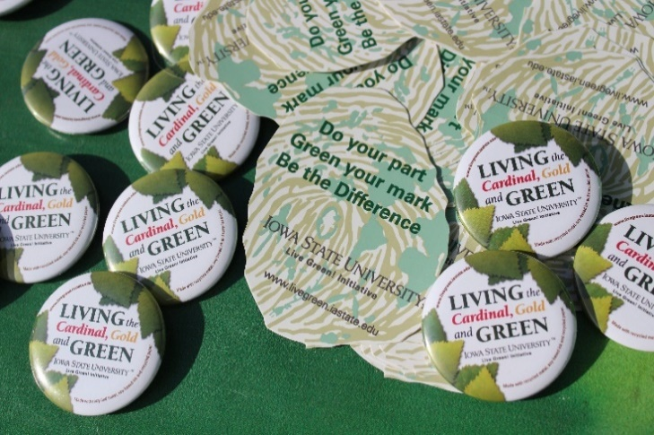 “Live Green! Initiatives” is an organization under the Office of Sustainability at Iowa State University and works towards a sustainable future. It was created to encourage all students, including alumni, and all faculty members to be committed and engaged in the effort of our campus to be as eco-friendly as possible. The organization holds ambition to make Iowa State

Fig. 1 NCSD 2017   
(ISU, November 16, 2018)

University a leader in sustainability among land-grant institutions (Iowa State University, Live Green! Initiative). The involvement and dedication of all Cyclones are critical to make changes happen. Related passages and information can be easily accessed on the homepage of “Live Green! Initiative”. Posters of upcoming events are also easily spotted and visible in the middle of the homepage.

“Live Green! Initiatives” has several events that invite guest speakers to our campus. This creates a bridge for the student to get connected with people who work in society for the purpose of promoting sustainability in the environment. Ideas can be exchanged and shared between authorities and students (Iowa State University, Live Green! Leadership Team). By doing so, students, faculty members, and staffs from distinctive departments would work together to collaborate their expertise and create a beneficial outcome to make the society acquainted with an eco-friendlier concept of living. To achieve its vision and mission, which goes along with the land-grant purposes, all students, faculty members, and staff are encouraged to participate in the organization. People who are interested can sign up to receive their newsletter via email through their websites. This ensures to always get notified for the most recent events. Interested individuals can email livegreen@iastate.edu or contact any board of committee for information. They can also attend any upcoming events and interact with the organization committee (Iowa State University, Live Green! Leadership Team).

The land-grant ideas include ideation such as women, minorities, and categories like the working class to be included in higher education. Second, universities should teach practical subjects such as engineering or agricultural related subjects. Third, universities should share knowledge with people throughout the states. Iowa State University’s vision is to achieve the land-grant ideas of putting science, technology, and human creativity to work and to provide a

community of scholars. Iowa State University has a mission of sharing knowledge beyond the campus borders. According to statistics, there are more than a million Iowans that are benefited directly from the Iowa State University Extension and Outreach program directly.

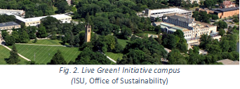 This program can never be progressed without a stable foundation. There are two documents that work as a foundation to achieve its vision and planning, “A Journey of Sustainability at Iowa State University” and “Envisioning Excellent in Sustainability at Iowa State University”. Both of these documents serve as a medium for all college departments, units, and organizations to communicate, expand their individual expertise, and develop collaborative goals (Iowa State University, Visionary Journey of Sustainability). Furthermore, there is a planned structure that works as tools and resources to help achieve the goals of the organization. First, there are four foundation pillars which work to support Iowa State University’s vision to be a model of energy efficiency and sustainability (Iowa State University, Visionary Journey of Sustainability). It offers all to learn more about sustainable activities and initiatives at Iowa State University. The addition sustainability infrastructures include teams such as Campus Sustainability Working Group and Sustainability Report Group to contribute to keep the greener practices and initiatives on track and remaining its systematic operations.

Efforts and initiatives are constantly being put in by organizers and authorities to lead the organization along with its vision and planning. Environmental issues are undoubtedly not an overnight issue, and hence, the speed of it erupting the ecosystem can only be slowed down through constant awareness and eco-friendlier practices carried out by the society. The university

as an institution to educate and guide the society has worked in contributing to the community and to the world. This organization has played a big role in guiding students to contribute to the community. “Live Green! Initiatives” is a purposeful outreach program that functions on the basis of all vision and mission of both the university and its land-grant status.

Citation

*Live Green! Working Toward a Sustainable Future.* Iowa State University, 1995,<https://www.livegreen.iastate.edu/>.  March 8, 2019.

“A Visionary Journey of Sustainability for Iowa State University.” *Live Green! Calendar | Office of Sustainability | Iowa State University*, 1995, [www.livegreen.iastate.edu/about-us/plan-and-vision](http://www.livegreen.iastate.edu/about-us/plan-and-vision) . March 8, 2019.

“Live Green! Leadership Team.” *Live Green! Calendar | Office of Sustainability | Iowa State University*, Iowa State University, [www.livegreen.iastate.edu/about-us/live-green-team](http://www.livegreen.iastate.edu/about-us/live-green-team). March 8, 2019.

Fig. 1. “NCSD 2017.” *Live Green! Calendar | Office of Sustainability | Iowa State University*, [www.livegreen.iastate.edu/multimedia/other-events-initiatives/national-campus-sustainability-day/ncsd-2017](http://www.livegreen.iastate.edu/multimedia/other-events-initiatives/national-campus-sustainability-day/ncsd-2017). March 8, 2019.

Fig. 2. “A Visionary Journey of Sustainability for Iowa State University.” *Live Green! Calendar | Office of Sustainability | Iowa State University*, 1995, [www.livegreen.iastate.edu/about-us/plan-and-vision](http://www.livegreen.iastate.edu/about-us/plan-and-vision) . March 8, 2019.